**NAME:** …………………………………………………………………………………………

**STREAM:** ………………………………………. **SIGNATURE:** ………………………………

**535/1**

**Physics**

**Paper 1**

**March, 2020**

**1 hr 40 min**



**Uganda certificate of education**

**PHYSICS MONTHLY TESTS**

**MARCH, 2020**

S.4 PHYSICS

**Paper one**

**Time allowed: 1 Hour 40 Minutes**

**INSTRUCTIONS TO CANDIDATES:**

Attempt ***all*** questions in this booklet

Answers to***Section A***must be placed in the answer table provided on***page 2***

Answers to***Section B***must be placed in the***spaces provided****.*

***All*** rough work must be done in **pencil** in this booklet at the last page.

***Where necessary assume;***

* Acceleration due to gravity, *g* = 10 ms-2
* Speed of sound in air = 320 ms-1
* Density of mercury = $1.36 × {10}^{3} {kgm}^{-3}$

**Turn over**

**PLEASE WRITE ANSWERS TO SECTION, A HERE:**

|  |  |  |  |  |  |  |  |  |  |  |
| --- | --- | --- | --- | --- | --- | --- | --- | --- | --- | --- |
| **1** |  |  | **9** |  |  | **17** |  |  | **25** |  |
|  |  |  |  |  |  |  |  |  |  |  |
| **2** |  |  | **10** |  |  | **18** |  |  | **26** |  |
|  |  |  |  |  |  |  |  |  |  |  |
| **3** |  |  | **11** |  |  | **19** |  |  | **27** |  |
|  |  |  |  |  |  |  |  |  |  |  |
| **4** |  |  | **12** |  |  | **20** |  |  | **28** |  |
|  |  |  |  |  |  |  |  |  |  |  |
| **5** |  |  | **13** |  |  | **21** |  |  | **29** |  |
|  |  |  |  |  |  |  |  |  |  |  |
| **6** |  |  | **14** |  |  | **22** |  |  | **30** |  |
|  |  |  |  |  |  |  |  |  |  |  |
| **7** |  |  | **15** |  |  | **23** |  |  | **31** |  |
|  |  |  |  |  |  |  |  |  |  |  |
| **8** |  |  | **16** |  |  | **24** |  |  | **32** |  |

**SECTION A**

1. Materials which **break** as soon as their elastic limit is exceeded are said to be
2. Ductile **C**. Plastic
3. Brittle **D**. Weak
4. A force of **2N** causes an extension of **0.4 cm** in a string. Find the force in newtons, required to cause a **0.3 cm** extension in the same string.
5. $\frac{2 × 0.3}{0.4}$**C**. $\frac{2 × 0.4}{0.3}$
6. $\frac{0.4 × 0.3}{2.0}$**D**. $2.0 ×0.3 ×0.4$
7. Which of the following properties of ***x*-rays** enables them to investigate a bone fracture?
8. They ionize gases
9. They darken a photographic plate
10. They travel in a straight line
11. They travel at the speed of light in a vacuum
12. (i) and (ii) only **C**. (ii) and (iii) only
13. (ii) and (iv) only **D**. (iii) and (iv) only
14. The activity of a radioactive substance X changes from 30 counts per minute to of a 3.75 counts per minute in 2 hours. Calculate the half-life
15. 30 minutes
16. 40 minutes
17. 37.5 minutes
18. 2 minutes
19. Which of the following energy changes occurs when a gun is cocked and a bullet fired from it?
20. Kinetic energy to potential energy
21. Chemical energy to kinetic energy
22. Sound energy to kinetic energy
23. Potential energy to kinetic energy
24. The **pressure exerted** by a solid on a surface depends on the
25. Mass of the solid and the area of contact
26. Volume of the solid and the area of contact
27. Weight of the solid and the time of contact
28. Density of the solid and the time of contact

**Turn Over**

1. 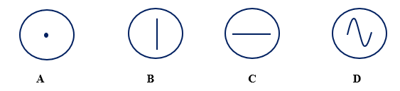Which of the following traces is obtained when a microphone is connected to a cathode ray oscilloscope and both ***x*** and ***y-*plates** are switched on?
2. From **Archimedes’** principle,
3. the up thrust is equal to the weight of the body immersed
4. the up thrust is equal to the weight of the displaces fluid
5. the up thrust is equal to the mass of the fluid displaced
6. the up thrust is equal the mass of the body immersed.
7. An arrow of mass 30 g is struck from a bow using 6 J of energy. The maximum speed of the arrow is
8. $\sqrt{\frac{6 ×30}{1000}}$ $ms^{-1}$**C**. $\sqrt{\frac{2 ×6}{30 × 1000}}$ $ms^{-1}$
9. $\sqrt{\frac{2 ×6 ×1000}{30}}$ $ms^{-1}$**D**. $\sqrt{\frac{2 ×30 ×1000}{6}}$ $ms^{-1}$
10. An oil drop of volume ${10}^{-4} {cm}^{3}$ spreads to form a patch of radius 2.5 cm. Estimate the thickness of the oil molecule
11. $5.1 × {10}^{-6} m$**C**. $5.1 × {10}^{-9} m$
12. $1.91 × {10}^{-6} m$**D**. $5.1 × {10}^{-9} cm$
13. A small phone battery is charged for two hours till full using a charger rated **‘d.c 5.0V, 500mA'**, calculate the maximum charge the battery can hold.
14. $5.0 × 2$ coulombs **C**. $5.0 ×2 ×500$ coulombs
15. $\frac{500 × 2 ×3600}{1000}$ coulombs **D**. $\frac{5.0 × 2 × 3600}{1000}$ coulombs
16. The figure below shows a wooden block of mass 3.5 kg lying on a rough horizontal table. If the coefficient of friction between the wood and the table is 0.14, calculate the force P required to move the block at an acceleration of 2 ${ms}^{-2}$

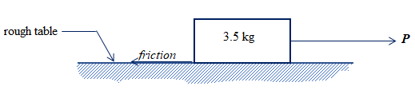

$P=\left(3.5 ×2.0\right)- \left(3 ×10 ×0.14\right) N$

$P=\left(3.5 ×2.0\right)+ \left(3 ×10 ×0.14\right) N$

$P= \left(3 ×10 ×0.14\right) N$

$P=\left(3.5 ×2.0\right) -0.14 N$

2. In a kitchen, smoke from the **concrete** **chimney** will
3. move out faster on a hot day because the chimney expands
4. move out faster on a hot day because the temperature outside is high
5. move out faster on a cold day because the temperature outside is low
6. move out slower on a cold day because the chimney contracts
7. Alpha – particles are more ionizing than beta-particles moving at the same speed because;
8. they have less mass, hence they are more energetic
9. they have more mass, hence they are less energetic
10. they are positively charged, hence they are more energetic
11. they have more mass, hence they are more energetic

1. Which of the following statements is/are true about identical dry cells arranged in parallel?
2. Effective e.m.f is the sum of all e.m.f’s
3. Effective e.m.f is equal to the e.m.f of only one cell
4. Effective internal resistance is the sum of all individual internal resistances
5. Effective internal resistance is the quotient of one internal resistance and their number
6. (i) only
7. (ii) and (ii) only
8. (ii) and (iv) only
9. (i) and (iii) only
10. Which of the following can be used to study wave forms?
11. X-ray tube **C**. cathode ray oscilloscope
12. Vacuum diodes **D**. Maltese cross tube
13. Which of the following changes when a force is applied on a body?
14. Mass
15. Velocity
16. Displacement
17. (i) and(ii) only **C**. (ii) and(iii) only
18. (i) and (iii) only **D**. (i), (ii) and (iii)
19. A ball of 3 kg moves at 10ms-1 towards a volley ball player. If the player hits the ball and it moves back with a velocity of 5 ms-1, find the change in momentum.
20. 3 (10 – 5) **C**. 3 (10 + 5)
21. $\frac{3 × 5}{10}$**D**. $\frac{3 × 10}{5}$

**Turn Over**

1. The figure below shows a rectangular structure ***ABCD*** under the action of force ***P***.

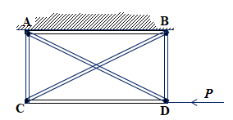

Which of the girders prevents the structure from shearing under ***P***?

1. AB **C**. BD
2. CD **D**. AD
3. Images formed by diverging mirrors are
4. laterally inverted
5. real
6. diminished
7. upside down
8. The equation below shows changes that occur when a nuclide $S$ decays to $T$.



Which one of the following radiations are emitted?

1. Two alpha particles
2. One beta particle and one alpha particle
3. Two beta particles
4. One alpha particle
5. A car radiator is painted black and filled with water because
6. Black bodies are good absorbers and emitters of heat
7. Water transfers heat by convection
8. Water is a poor conductor of heat
9. (i) and (ii) only **C**. (i) and (iii) only
10. (iii) only **D**. (ii) only
11. The reluctance of a body to remain in motion depends on its
12. Mass
13. Velocity
14. Direction of motion
15. (i) only C. (i) and (ii) only
16. (i) , (ii) and (iii) D. (ii) and (iv) only
17. 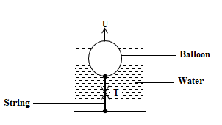The figure below shows a balloon inflated with air and tied to the bottom of a water tank using a string. If ***W*** is the weight of the balloon and ***T***, the tension in the string, which of the following is correct?
$U+ W = T$

$W= U + T$

$T = W + U$

$T = U - W$

18. The figure below shows the motion graph of a car. The car is at rest;

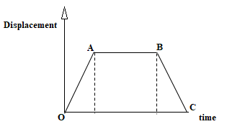

1. between O and A
2. between A and B
3. between B and C
4. between O and C
5. 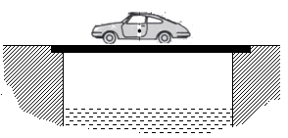The figure below shows a car moving over a bridge.

Which of following is true about the mechanical structural state the bridge layers?

|  |  |  |  |
| --- | --- | --- | --- |
|  | *Upper layer* | *Middle layer* | *Under layer* |
| **A** | Under compression | Neutral | Under tension |
| **B** | Under tension | Neutral | Under compression |
| **C** | Under tension | Neutral | Under tension |
| **D** | Under compression | Under tension | Under compression |

**Turn Over**

1. Two insulators **Y** and **Z** are rubbed together. **Z** loses electrons to **Y**. Which of the following happens when **Z** is brought near the cap of a positively charged gold leaf electroscope?
2. The leaf diverges further
3. The leaf collapses
4. The leaf collapses and then diverges
5. The leaf remains stationary
6. The efficiency of a simple machine can be increased by
7. Increasing the effort
8. Increasing the effort distance
9. Increasing the load
10. (i) and (ii) only
11. (ii) and (iii) only
12. (i) and (iii) only
13. (iii) only

1. An object of height 12 cm is placed 24 cm in front of a pinhole camera in which the screen is 8 cm from the hole. The image received is;
2. Erect and 4 cm tall
3. Inverted and 4 cm tall
4. Erect and 16 cm tall
5. Inverted and 12 cm tall
6. A sphere of radius 15 cm floats with ½ of it submerged in water. Calculate the volume of water displaced.
7. cm3 **C**. cm3
8. cm3 **D**. cm3
9. The acceleration of a body depends on
10. Force applied only
11. Mass of the body only
12. Force applied and mass of the body
13. Mass of the body and time for which the force is applied
14. 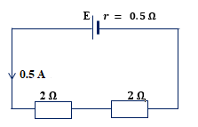The figure shows a cell of emf E, and internal resistance, 0.5 $Ω$ connected to two 2 $Ω$ resistors arranged as shown. Calculate the emf of the cell
15. 2.25V **C**. 9.0 V
16. 2.0 V **D**. 2.5 V

**SECTION B**

1. (a) What is meant by the term **up-thrust**? **(01 mark)** ………………………………………………………………………………………………

………………………………………………………………………………………………

(b) A block of wood of volume $1.2 × {10}^{-3} m^{3 }$ floats in water of density ${10}^{3} kgm^{-3 }$ floats in water with $4/5$ of its volume submerged.

(i) Sketch a diagram to show the forces acting on the block in equilibrium **(01 mark)**

(ii) determine the **density** of the wood block. **(02 marks)**

………………………………………………………………………………………………………………………………………………………………………………………………………………………………………………………………………………………………………………………………………………………………………………………………………………………………………………………………………………………………………………………………………………………………………………………………………………………………

1. (a) State two differences between ***x*-rays** and **cathode rays** **(02 mark)**

……………………………………………………………………………………………………………………………………………………………………………………………………………………………………………………………………………………………………………………………………………………………………………………………… **Turn Over**

(b) The figure below is of an ***x*-ray** tube.

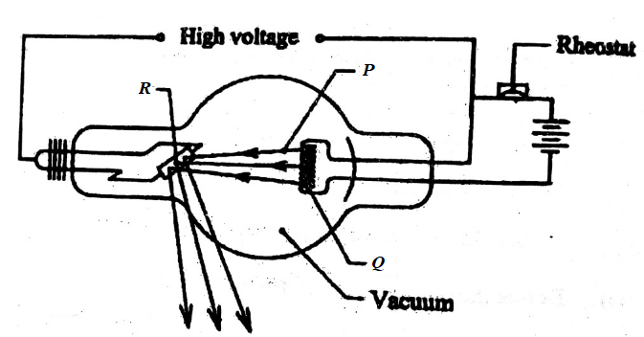

1. Name the parts labelled **P** and **Q** **(01 mark)**

**P** = ………………………………………………………………

**Q** = ………………………………………………………………

1. Of what importance is the part labeled **R**? **(01 mark)**

……………………………………………………………………………………………………………………………………………………………………………………………………………………………………………………………………………………………………….

1. (a) What is meant by **emf** of a cell? **(01 mark)**

………………………………………………………………………………………………………………………………………………………………………………………………………….

(b) State two ways of **increasing** the resistance of a conductor. **(01 mark)**

……………………………………………………………………………………………………………………………………………………………………………………………………………………………………………………………………………………………………………………………………………………………………………………………………………………

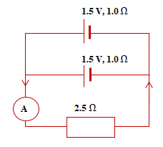(c) The figure below shows two identical cells of emf **1.5 V** and internal resistance **1.0 $Ω$**  connected to a **2.5 $Ω$**  resistor as shown. Calculate the ammeter reading. **(02 marks)**

……………………………………………………………………………………………………………………………………………………………………………………………………………………………………………………………………………………………………………………………………………………………………………………………………………………

1. (a) What is **fluorescence**? (01 mark)

…………………………………………………………………………………………………………………………………………………………………………………………………………

(b) (i) State the energy changes that occur when a **torch bulb** lights from a **dry cell** (01 mark)

…………………………………………………………………………………………………………………………………………………………………………………………………………

(ii) Explain why a **parabolic mirror** is preferred to a **concave mirror** for use as a torch reflector. (02 marks)

……………………………………………………………………………………………………………………………………………………………………………………………………………………………………………………………………………………………………………………………………………………………………………………………………………………

1. (a) Define the **frequency** as applied to waves. (01 mark)

…………………………………………………………………………………………………………………………………………………………………………………………………………

1. A wave has a frequency of **50 Hz**. Calculate the period of its source. (01 mark)

……………………………………………………………………………………………………………………………………………………………………………………………………………………………………………………………………………………………………………………………………………………………………………………………………………………

1. Explain why a good solar panel should be **curved** and painted **black**. (02 marks)

……………………………………………………………………………………………………………………………………………………………………………………………………………………………………………………………………………………………………………………………………………………………………………………………………………………

**END**

**With determination, you too can!**